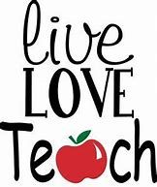
I decided to focus this webpage on teaching English Language Learners students many techniques on how to decode or read in English. I personally have a connection with this topic because I was once an English Language Learner myself. I can relate to the multiple struggles that many English Language Learners encounter. I came from Honduras when I was nine years old. I am the oldest of six siblings, and I often found myself struggling trying to learn and understand a new language. Looking back at my early education years in this country, back in the early 90s, I recognized that there was not enough support for English Language Learners. I became an educator with the aspirations of extending a hand to my English Language Learners acquired the language as well as inspired many of them to fulfill their “American Dreams”. I take pride in teaching fifth-grade bilingual students in the Brentwood School District. It fulfills my heart to know that my dedication, school preparation at Molloy College and my hard work are working together to shape the lives of many of my students. Providing my students with the tools they need to succeed is extremely rewarding.
Sincerely,
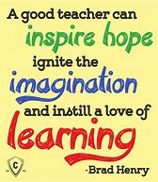
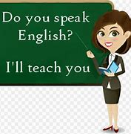
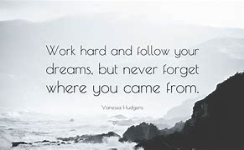
Mrs. Ascencio

